Obstetrical nursing and midwife.

EXERCISE 1. Read and learn the following words:
midwifery [ˈmɪdwɪfərɪ]-окушерство
prenatal [ˈpri:ˈneɪtl]-дородовый
attempting[əˈtemptɪŋ]-пытающиеся
currently[ˈkʌrəntli]-в настоящее время
provide [prəˈvaɪd]-обеспечивать
experiencing[ɪkˈspɪərɪənsɪŋ]-испытывающий
supervision [ˌsju:pəˈvɪʒən]-контроль, наблюдение
technician [tekˈnɪʃən]-специалист, человек, знающий свое дело
technologist [tekˈnɔlədʒɪst]-специалист
evaluation [ɪˌvæljuˈeɪʃən]-оценочный
assessment [əˈsesmənt]-оценка
possess [pəˈzes]-обладать
resuscitation[rɪˌsʌsɪˈteɪʃən]- реанимация новорождённых;
drip [drɪp]-вливание
sexual [ˈseksjuəl]-половой
midwife [ˈmɪdwaɪf]-акушерка
regardless [rɪˈɡɑ:dlɪs]-независимо от
gender [ˈdʒendə]-пол
relate [rɪˈleɪt]-иметь отношение к
annual [ˈænjuəl]-ежегодный
postpartum[ˌpəʊstˈpɑːtəm]- постнатальный, послеродовой
recognize[ˈrɛkəɡnʌɪz]-распознавать
progress [ˈprəʊɡres]-развитие
deviation[ˌdiːviˈeɪʃn]-отклонение
discern [dɪˈsəːn]-заметить
intervene [ˌɪntəˈvi:n]-вмешиваться
posterior[pɔsˈtɪərɪə]-ягодичное
non-invasive [nɔn ɪnˈveɪsɪv]- неинвазивный метод

EXERCISE 2. Give the Russian equivalents to the following word combinations before reading the text:
Obstetrical nursing, currently pregnant, recently delivered, the patients experiencing pregnancy complications, the nurse practitioners, the patient care technicians, the surgical technologists, the postoperative care, stress test evaluations, health assessments, neonatal resuscitation, intravenous drip, the postpartum period, regardless of gender, annual gynecological exams, the variations of normal progress of labor, deviations from, the high risk situations, non-invasive techniques.

EXERCISE 3. Read and translate the text.

Obstetrical nursing and midwifery

Obstetrical nursing, also called prenatal nursing, is a nursing specialty that works with patients who are attempting to become pregnant, are currently pregnant, or are recently delivered. Obstetrical nurses help to provide prenatal care and testing, care of patients experiencing pregnancy complications, care during labor and delivery, and care of patients following delivery. Obstetrical nurses work closely with obstetricians, midwives, and nurse practitioners. They also provide supervision of patient care technicians and surgical technologists.
Obstetrical nurses perform postoperative care on a surgical unit, stress test evaluations, cardiac monitoring, vascular monitoring, and health assessments. Obstetrical nurses must possess specialized skills including electronic fetal monitoring, neonatal resuscitation, and medication administration by continuous intravenous drip.
Midwifery is a branch of health sciences that deals with pregnancy, childbirth, and the postpartum period (including care of the newborn), besides sexual and reproductive health of women throughout their lives. A professional in midwifery is known as a midwife; the term is only indirectly related to the word "wife" and is used regardless of gender, although most midwives are indeed female. The related medical speciality is known as obstetrics.
Midwifery, in addition providing care to women during pregnancy and birth, may also provide primary care related to reproductive health, including annual gynecological exams, family planning, and menopausal care.
Midwifery specializes in childbirth, postpartum, and well-woman health care. The midwives are educated and trained to recognize the variations of normal progress of labor and deal with deviations from normal to discern and intervene in high risk situations, such as twin births and births where the baby is in a posterior position, using non-invasive techniques.

EXERCISE 4. Answer the following questions:
1. What is obstetrical nursing? 2. Whom does the prenatal nurse work with? 3. How do obstetrical nurses work with obstetricians, midwives, and nurse practitioners? 4. What do they also provide? 5. What must obstetrical nurses possess? 6. What is midwifery?

EXERCISE 5. Chose the appropriate word
1. Obstetrical nursing, also called _________nursing, is a nursing specialty that works with patients who are attempting to become pregnant, are currently pregnant, or are recently delivered.
a) surgical; b) registered; c) prenatal
2. Obstetrical nurses perform __________ care on a surgical unit, stress test evaluations, cardiac monitoring, vascular monitoring, and health assessments.
a) preoperative; b) postoperative; c) during operation
3. Midwifery specializes in ___________, postpartum, and well-woman health care.
a) childbirth; b) bandaging; c) laboratory tests

EXERCISE 6. Find English equivalents from the text:
1.Предродовой уход___________________________
2. Кто пытается забеременеть ____________________
3. Недавно рожавшие __________________________
4. Пациентки, испытывающие осложнения беременности_____________________
5. Профессиональные медсестры__________________
6. Наблюдение специалистов по уходу за пациентами________________________
7. Послеоперационный уход при хирургическом вмешательстве_______________
EXERCISE 7. Look at the picture and tell what kind of nurse do you see?

 | 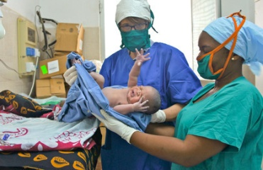
a)________________________ | b)__________________

EXERCISE 8. Match the beginning of the sentence to its ending

- Obstetrical nurses help | - a branch of health sciences that deals with pregnancy, childbirth, and the postpartum period.
- Obstetrical nurses perform | - to recognize the variations of normal progress of labor
- Midwifery is | - childbirth, postpartum, and well-woman health care.
- Midwifery specializes in | - postoperative care on a surgical unit, stress test evaluations, cardiac monitoring, vascular monitoring, and health assessments.
- The midwives are educated and trained | - to provide prenatal care and testing, care of patients experiencing pregnancy complications, care during labor and delivery, and care of patients following delivery.

Childbirth.
Exercise 1. Read and learn the following words.
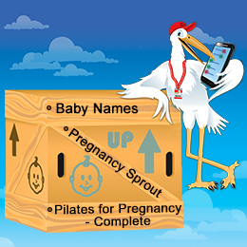
childbirth [ˈtʃaɪldbə:θ]-роды
labor [ˈleɪbə]-роды
previously [ˈpri:vjəslɪ]-ранее, предварительно
average [ˈævərɪdʒ]-составлять в целом
thinning [ˈθɪnɪŋ]-утончаться
effacement [ɪˈfeɪsmənt]-сглаживаться
dilation [daɪˈleɪʃən]-расширение
contraction [kənˈtrækʃən]-сокращение
mild [maɪld]-спокойный
apart [əˈpɑ:t]-примерно
membrane [ˈmembreɪn]-мембрана
rupture [ˈrʌptʃə]-разрывать
releasing [rɪˈliːsɪŋ]-высвобождать
amniotic [amnɪˈɒtɪk]-амниотический
expulsion [ɪksˈpʌlʃən]-изгнание, выталкивание
rectum [ˈrektəm]-прямая кишка
strong [strɔŋ]-сильный
urge [ə:dʒ]-желание
push [puʃ]-тужиться
expel [ɪksˈpel]-удалять

Exercise 2. Translate the following words and word combinations from English into Russian.
The first time mother, three stages, the beginning of labor, dilation of the cervix, complete effacement, the longest part of labor, the latent phase, the active phase, amniotic fluid, the membranes rupture, vaginal bleeding, the fetal expulsion, the second stage, the uterus contracts,
the third stage.

Exercise 3. Read and translate the text.
Text Labor

Labor is usually shorter in women who have previously had children than in first time
mothers. The average labor is anywhere from 12 to 24 hours. Labor is typically
divided into three stages, with the first stage having two phases. The first
stage starts with the beginning of labor, when uterine contractions which result
in thinning (effacement) and dilation of the cervix. The first stage of labor ends
with full dilation, at 10 cm, and complete effacement. This is the longest part of
labor. Contractions are milder, last 60 to 90 seconds, and are 15 to 20 minutes apart
in this first phase of labor, termed the latent phase. The active phase occurs when
the cervix dilates from 4 to 8 cm, contractions become stronger, last about 30 to
45 seconds, and are closer together. This is often when the membranes rupture,
releasing amniotic fluid. A backache is common, as is some vaginal bleeding.
When the cervix is fully dilated at 10 cm, the second stage of labor has started.
This phase is fetal expulsion. Contractions continue, but feel different. There is
pressure on the rectum, and a strong urge to push. The second stage of labor ends
with the birth of the baby. Delivery of the placenta, or afterbirth, is the third stage
of labor. Contractions will continue, but will be milder, as the uterus contracts,
which helps to expel the placenta and slow the bleeding.
Exercise 4. Answer the following questions.
1. What is labor? 2. How many stages is labor typically divided into? 3. How many phases have the first stage? 4. How does the first stage start? 5. How does the first stage end? 6. What is the longest part of labor? 7. What happens when the cervix is fully dilated at 10 cm? 8. What happens in the end of the second stage? What is the third stage of labor?

Exercise 5. Look at the pictures and tell what the stage of labor is:

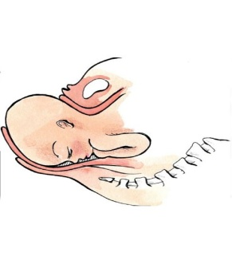  picture 1 | 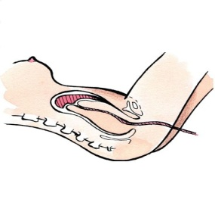  picture 2 | 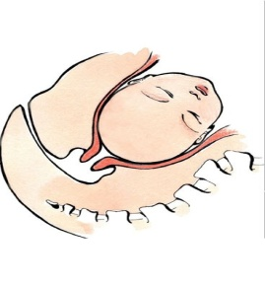  picture 3

Picture 1 __________________________________________________
Picture 2 __________________________________________________
Picture 3 __________________________________________________

Exercise 6. Match English words and word combinations (1–7) to Russian equivalents (a, b, c, d, e, f, g)
- The beginning of labor | - разрыв мембранных оболочек
- The dilation of the cervix | - сокращения матки
- The membranes rupture | - раскрытие шейки матки
- The vaginal bleeding | - начало родов
- Contractions of the uterus | - вагинальное кровотечение
- The second stage | - изгнание планцеты
- To expel the placenta | - вторая стадия

Exercise 7. Fill in the gaps with the words in the box

a) dilation; b) average; c) the birth; d) the placenta; e) contractions; f) Labor

1. The ________ labor is anywhere from 12 to 24 hours.
2. _________ is typically divided into three stages, with the first stage having two phases.
3. The first stage of labor ends with full _________, at 10 cm, and complete effacement.
4. The active phase occurs when the cervix dilates from 4 to 8 cm, ______become stronger, last about 30 to 45 seconds, and are closer together.
5. The second stage of labor ends with ________of the baby.
6. Delivery of _________, or afterbirth, is the third stage of labor.
Exercise 8. Translate the Russian part of the sentence into English
1. В среднем по времени is anywhere from 12 to 24 hours.
2. The first stage starts with the beginning of labor, when uterine contractions which result
in thinning and расширением шейки.
3. Активная фаза происходит когда шейка расширяется от 4 до 8 сантиметров, contractions become stronger, last about 30 to 45 seconds, and are closer together.
4. Когда шейка полностью расширена на 10 сантиметров, the second stage of labor has started.
5. Сокращения будут продолжатся, но они будут более умеренными, as the uterus contracts, which helps to expel the placenta and slow the bleeding.

