Gynecology
Exercise 1. Read and learn the following words.

genital [ˈdʒenɪtl]- половая
reproductive [riːprəˈdʌktɪv] -репродуктивный
uterus [ˈju:tərəs]- матка
womb [wu:m] - матка
fetus [ˈfi:təs]- зародыш, плод
cervix [ˈsə:vɪks] - шейка
vagina [vəˈdʒaɪnə]- влагалище
ovary [ˈəuvərɪ] - яичник
hormone [ˈhɔ:məun] - гормон
fallopian [fəˈləupɪən-] – фаллопиева
menstrual [ˈmenstruəl]- менструальный
menstruate [ˈmenstrueɪt]- менструировать
shed [ʃed]-менять, изливать
lining [ˈlaɪnɪŋ]- внутренний слой
fertilization [ˌfə:tɪlaɪˈzeɪʃən]- оплодотворение
pregnancy [ˈpreɡnənsɪ] - беременность
menopause [ˈmenəupɔ:z] - менопауза
primary [ˈpraɪmərɪ]- основной
goal [ɡəul]- цель
gynecologist [gaɪnɪˈkɔlədʒɪst]- гинеколог
guide [ɡaɪd] – вести, проводить
ensure [ɪnˈʃuə]-обеспечивать, гарантировать
retain [rɪˈteɪn]- сохранять, поддерживать
throughout [θru:ˈaut]- на протяжении
stage [steɪdʒ] – стадия
pertains[pə:ˈteɪn]-относиться
caesarian [sɪˈzɛərɪən]- кесарево
section [ˈsekʃən]- сечение, разрез

Exercise 2. Read and translate the text.

Gynecology.

Gynecology is the specialized field of medicine dealing with the health of a woman's genital system. The genital system consists of the reproductive organs, including the uterus (the womb; the organ in which a fetus develops), cervix (the opening between the uterus and the vagina), ovaries (organs that produce eggs and sex hormones), fallopian tubes (organs that carry eggs from the ovaries to the uterus), vagina (the muscular tube that extends from the uterus to outside the body), as well as their supporting structures.
Significant changes occur in a woman's reproductive organs when she reaches the first menstrual period. Menarche is the age at which a woman begins to menstruate. (Menstruation is the monthly cycle in no pregnant women during which the uterus sheds its lining when fertilization of an egg does not take place.) Other changes occur again during any pregnancy that occurs in her life. A third important period of change occurs during menopause, at which time a woman ceases menstruating. A primary goal of the gynecologist is to guide women through these changes in their lives and to ensure that they retain their health throughout each stage.
Obstetrics is the division of medicine that focuses on the care of women during pregnancy, childbirth and the time immediately following childbirth. Obstetrics also includes the practice of surgery pertains to childbirth, including caesarian section, also known as C-section.
The practice of obstetrics is often combined with gynecology, the specialty of women's reproductive health.
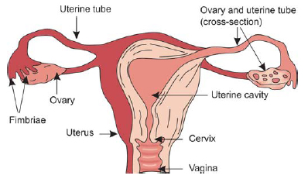

Exercise 3. Answer the following questions:
- What is gynecology?
- What does the genital system consist of?
- How many the reproductive organs are there in the woman body?
- What are they?
- When do significant changes occur in a woman's reproductive organs at first?
- When do other changes occur in a woman's reproductive organs?
- What is obstetrics?
- What does obstetrics also include?

Exercise 4. Translate the following words and word combinations from Russian into English.
The specialized field, the genital system, the reproductive organs, sex hormones, fallopian tubes, the muscular tube, the supporting structures, significant changes, no pregnant women, caesarian section.

Exercise 5. Complete the sentences with the words from the box.
a) obstetrics, b) pregnancy, c) menstrual period, d) C-section, e) the gynecologist, f) gynecology.

- …………. is the specialized field of medicine dealing with the health of a woman's genital system.
- Significant changes occur in a woman's reproductive organs when she reaches the first ……….. ……. .
- Other changes occur again during any ………… that occurs in her life.
- A primary goal of …………. is to guide women through these changes in their lives and to ensure that they retain their health throughout each stage.
- ……………… is the division of medicine that focuses on the care of women during pregnancy, childbirth and the time immediately following childbirth.
- Obstetrics also includes the practice of surgery pertains to childbirth, including caesarian section, also known as ………… .

Exercise 6. Define the meaning of the following words. Match the words (a-e) to (1–5)
- the uterus | - the opening between the uterus and the vagina
- cervix | - organs that produce eggs and sex hormones
- fallopian tubes | - the womb; the organ in which a fetus develops
- vagina | - organs that carry eggs from the ovaries to the uterus
- ovaries | - the muscular tube that extends from the uterus to outside the body

Exercise 7. Label the diagram (1–5)

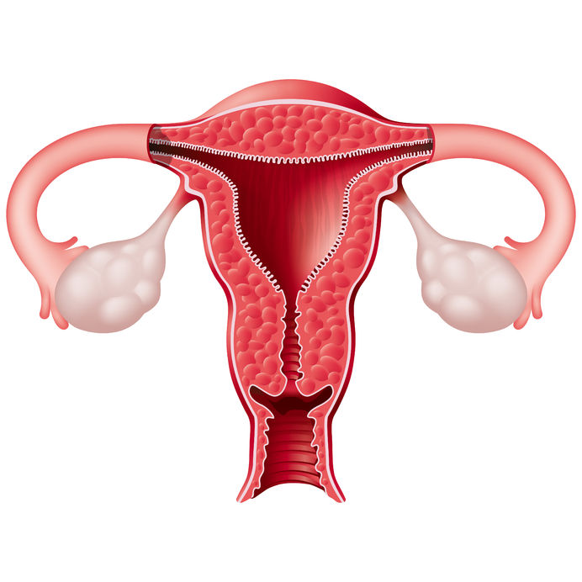
3……………
5…………….
4……………
1……………
2…………… ………………………………

Exercise 8. Read and learn the following words.

pregnancy [ˈpreɡnənsɪ] - беременность
gravidity [ græʹvıdıtı ] - беременность
gestation [ dʒesˈteɪʃ(ə)n ] - беременность
offspring[ ˈɔfsprɪŋ ]-плод
divide [dɪˈvaɪd]- делить
trimester [traɪˈmestə]- триместр
through [θru:]- в течении
conception [kənˈsepʃən]- зачатие
fertilize [ˈfə:tɪlaɪz]- оплодотворять
attache [əˈtætʃ]- прикрепляться
fetus [ˈfi:təs]- зародыш, плод
placenta[pləˈsentə]- планцета
miscarriage[mɪsˈkærɪdʒ]- самопроизвольный аборт
embryo [ˈembrɪəu]- эмбрион
survive [səˈvaɪv]- выживать, удерживаться
provide [prəˈvaɪd]- обеспечивать
prenatal [ˈpri:ˈneɪtl]- предродовый
improve [ɪmˈpru:v]- улучшать
outcome [ˈautkʌm]- исход
complication [ˌkɔmplɪˈkeɪʃən]- осложнение
pressure [ˈpreʃə]- давление
gestational [je`stāshənəl]- гестационный
diabetes [ˌdaɪəˈbi:ti:z]- диабет
anemia [əˈniːmɪə]- анемия
severe [sɪˈvɪə]- серьезный, тяжелый
nausea [ˈnɔ:sjə]- тошнота
vomit [ˈvɔmɪt]- рвота
term [tə:m]- срок
preterm[priːˈt3ːm]- недоношенный
cerebral [ˈserɪbrəl]- церебральный
palsy [ˈpɔ:lzɪ]- паралич
induction [ɪnˈdʌkʃən]- стимуляция
lanugo [ ləʹnju:gəʋ]- пушок ( на коже зародыша, эмбрионе )

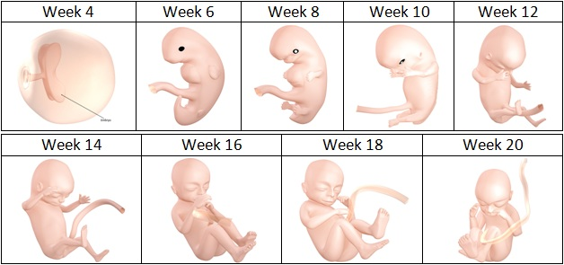

Exercise 9. Read and translate the text.
Pregnancy.
Pregnancy, also known as gravidity or gestation, is the time during which one or more offspring develops inside a woman. It usually lasts around 40 weeks from the last menstrual period (LMP) and ends in childbirth.
Pregnancy is typically divided into three trimesters. The first trimester is from week one through 12 and includes conception. Conception is when the sperm fertilizes the egg. The fertilized egg then travels down the fallopian tube and attaches to the inside of the uterus, where it begins to form the fetus and placenta. The first trimester carries the highest risk of miscarriage (natural death of embryo or fetus). The second trimester is from week 13 through 28. Around the middle of the second trimester, movement of the fetus may be felt. At 28 weeks, more than 90% of babies can survive outside of the uterus if provided high-quality medical care. The third trimester is from 29 weeks through 40 weeks.
Prenatal care improves pregnancy outcomes. Prenatal care may include taking extra folic acid, avoiding drugs and alcohol, regular exercise, blood tests, and regular physical examinations. Complications of pregnancy may include high blood pressure of pregnancy, gestational diabetes, iron-deficiency anemia, and severe nausea and vomiting among others. Term pregnancy is 37 to 41 weeks, with early term being 37 and 38 weeks, full term 39 and 40 weeks, and late term 41 weeks. After 41 weeks, it is known as post term. Babies born before 37 weeks are preterm and are at higher risk of health problems such as cerebral palsy. Delivery before 39 weeks by labor induction or caesarean section is not recommended unless required for other medical reasons.
https://en.wikipedia.org/wiki/Pregnancy

Exercise 10. Discuss at what stages of pregnancy you think the following events happen. For each one, choose a number of weeks from those below.
Number of weeks: 3 7 12 18 22 34
- The lowest number of weeks at which a premature baby can survive. _____
- The fetus’s fine covering of the hair, called lanugo, begins to disappear. _____
- Arm buds and a tail are visible. _____
- The embryo measures 30 mm in length._____
- Male and female genitals appear well differentiated. _____
- The fetal heartbeat can be heard with a stethoscope. _____

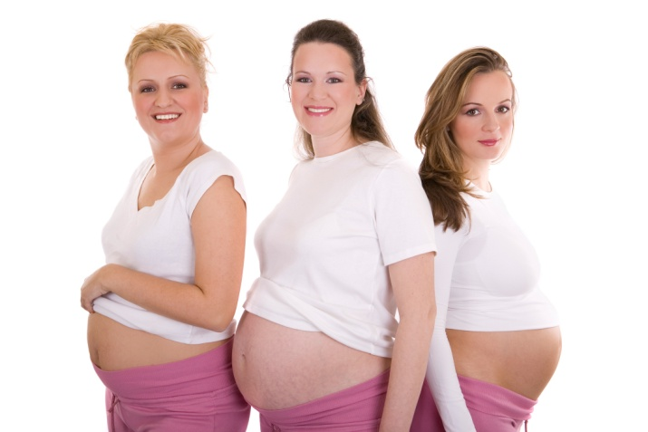

Exercise 11. Answer the following questions:

- Is pregnancy a period of excitement and expectancy?
- What period is more important for the future mother?
- Is it harmful to take some pills during the pregnancy?
- How many trimesters is pregnancy typically divided into?
- What is conception?
- How long does the first trimester last?
- How long does the second trimester last?
- How long does the third trimester last?
- What does prenatal care improve?
- What babies are preterm and are at higher risk of health problems such as cerebral palsy?

Exercise 12. Translate these words and word combinations from Russian into English.
Менструальный цикл, роды, беременность, зачатие, оплодотворённая яйцеклетка, фаллопиева труба, высокий риск, выкидыш, медицинский уход в период беременности, исключение алкоголя и курения, анализы крови, регулярные физические осмотры, (диабет, обусловленный беременностью), недоношенный ребенок, церебральный паралич, проблемы со здоровьем, переношенный ребенок.

Exercise 13. Match the beginning of the sentences to their endings.
Pregnancy is typically divided | from week 13 through 28
The first trimester is | from 29 weeks through 40 weeks.
The second trimester is | from week one through 12 and includes conception.
The third trimester is | extra folic acid, avoiding drugs and alcohol, regular exercise, blood tests, and regular physical examinations.
Prenatal care may include taking | into three trimesters.

Exercise 14. Chose the appropriate word:
Pregnancy, also known as gravidity or gestation, is the time (during, after, above) which one or more offspring develops inside a woman.
Pregnancy usually lasts around 40 (days, years, weeks) from the last menstrual period (LMP) and ends in childbirth.
The fertilized egg then (flies, travels, swims) down the fallopian tube and attaches to the inside of the uterus, where it begins to form the fetus and placenta.
The first trimester carries( the highest, the lowest, middle) risk of miscarriage (natural death of embryo or fetus).
Prenatal care may include taking extra folic acid, (taking, saving, avoiding) drugs and alcohol, regular exercise, blood tests, and regular physical examinations.
Exercise 14. Find 10 words in the crossword(↓, →, ↑). Write them down and read.

p | r | e | g | n | a | n | c | y
r | v | g | n | f | c | j | a | p
e | b | g | d | t | i | v | r | h
n | d | u | x | h | d | n | e | e
a | n | e | m | i | a | r | a | m
t | r | i | m | e | s | t | e | r
a | k | j | f | e | t | u | s | e
l | a | b | o | r | v | o | l | t

1…………………………..
2…………………………..
3…………………………..
4…………………………..
5…………………………..
6…………………………..
7…………………………..
8…………………………..
9…………………………..
10…………………………
Exercise 15. Read and learn the following words.

mental [ˈmentl]- умственный
growth [ɡrəuθ]- рост
principal [ˈprɪnsəpəl]- основной
rapid [ˈræpɪd]- быстрый
nutritious [nju:ˈtrɪʃəs]- питательный
essential [ɪˈsenʃəl]- необходимый
carbohydrate [ˈkɑ:bəuˈhaɪdreɪt]- углевод
vegetable [ˈvedʒɪtəbl]- овощ
grain [ɡreɪn]- зерно
alternative [ɔ:lˈtə:nətɪv]- схожий
spicy [ˈspaɪsɪ]- острый
chocolate [ˈtʃɔkəlɪt]- шоколад
sugary [ˈʃuɡərɪ]- сладкий
candy [ˈkændɪ]- конфетта
soda [ˈsəudə]-содовая, лимонад
calcium [ˈkælsɪəm]- кальций
cleft [kleft]- зайчья
lip [lɪp]- губа
congenital [kənˈdʒenɪtl]- врожденный
fuel [fjuəl]- питать
hemoglobin [ˌhi:məuˈɡləubɪn]- гемоглобин
shortage [ˈʃɔ:tɪdʒ]- недостаток, нехватка
double [ˈdʌbl]- удваивать
quantity [ˈkwɔntɪtɪ]- количество
cell [sel]- клетка
maternal [məˈtə:nl]- материнское
supply [sə'plaɪ]- снабжение
muscle [ˈmʌsl]- мышца
tissue [ˈtɪʃu:]- ткань
approximately [əˈprɔksɪmɪtlɪ]- пиблизительно

Exercise 16. Read and translate the text.

Healthy Diet for Pregnant Women.
A well balanced diet is more important when women are pregnant. The first three months of pregnancy is important as most of the physical and mental growth of the baby takes place during this time. The principal organs both external and internal and the nervous system of the baby form within this period. So it is important to eat well from the beginning of pregnancy and even if pregnant women have discomforts like nausea, vomiting etc. The fetus growth is rapid during the last three months of pregnancy. A nutritious diet during this period is essential for normal birth weight of the baby.
A nutritious diet with enough proteins, fats, carbohydrates, minerals and vitamins are essential during pregnancy. For pregnant women diet should consist of a variety of foods selected from the five basic food groups. Fresh fruits and vegetables, whole grain products like breads or cereals, meat, fish or other protein alternatives, milk and other dairy products provide a nutritious diet. The pregnant woman should avoid spicy foods, coffee, hot chocolate, sugary foods such as cakes, cookies, candies, sodas and colas and reduce salt intake as far as possible.
Besides the natural diet, prenatal vitamins especially iron, calcium, folic acid are often prescribed routinely through the pregnancy by the doctor.
Some of the essential nutrients
Folic acid: Folic acid is the most vital nutrient pregnant women need. This is needed for the development of baby's nervous system, especially in the first few weeks. Folic acid is a B vitamin that helps prevent neural organs defects (defects of the spine, brain, or their coverings) and other birth defects like cleft lip and congenital heart disease.
Iron: Iron is needed to fuel hemoglobin production for pregnant woman and her baby. Iron also helps build bones and teeth. A shortage of iron can cause a condition called anemia.
Calcium : This is vital for the healthy development of your baby's bones and teeth, which start to form at about week eight. The pregnant woman need about double the quantity of calcium than is normal.
Protein is a component of everybody cell and important for building the maternal blood supply. Protein also is necessary for fetal hair, skin, muscle, nerve tissue and brain development. Women need approximately 10 more grams of protein daily – a total of 60 grams a day – during the pregnancy.
Exercise 17. Find English equivalents in the text.
Хорошо сбалансированная диета, первые три месяца беременности, психическое развитие плода, основные органы, нервная система, беременная женщина, рост зародыша, питательная диета, нормальный вес при рождении ребенка, различная пища, молочные продукты, свежие фрукты, избегать острую пищу, естественная диета, фолиева кислота, заячья губа, врожденная болезнь сердца, выработка гемоглобина, нехватка железа, здоровое развитие, двойное количество кальция.

Exercise 18. Read the sentences. Are these statements true (T) or false (F)?
- A well balanced diet is not important when women are pregnant.
- The first three months of pregnancy is important as most of the physical and mental growth of the baby takes place during this time.
- The fetus growth is slowly during the last three months of pregnancy.
- The pregnant woman should eat spicy foods, coffee, hot chocolate, sugary foods such as cakes, cookies, candies, sodas and colas and reduce salt intake as far as possible.
- Besides the natural diet, prenatal vitamins especially iron, calcium, folic acid are often prescribed routinely through the pregnancy by the doctor.

Exercise 19. Vitamins. Table of nutrients and vitamins for pregnancy. Translate it into Russian in written form.
Essential Vitamin/Mineral: | Why You Need It: | Where You Find It:
Vitamin A & Beta Carotene (770 mcg) | Helps bones and teeth grow | Liver, milk, eggs, carrots, spinach, green and yellow vegetables, broccoli, potatoes, pumpkin, yellow fruits, cantaloupe.
Vitamin D (5 mcg) | Helps body use calcium and phosphorus; promotes strong teeth and bones | Milk, fatty fish, sunshine.
Vitamin E (15 mg) | Helps body form and use red blood cells and muscles | Vegetable oil, wheat germ, nuts, spinach, fortified cereals
Vitamin C (80 – 85 mg) | An antioxidant that protects tissues from damage and helps body absorb iron; builds healthy immune system | Citrus fruits, bell peppers, green beans, strawberries, papaya, potatoes, broccoli, tomatoes
Thiamin/B1 (1.4 mg) | Raises energy level and regulates nervous system | Whole grain, fortified cereals, wheat germ, organ meats, eggs, rice, pasta, berries, nuts, legumes, pork
Riboflavin/B2 (1.4 mg) | Maintains energy, good eyesight, healthy skin | Meats, poultry, fish, dairy products, fortified cereals, eggs
Niacin/B3 (18 mg) | Promotes healthy skin, nerves and digestion | High-protein foods, fortified cereals and breads, meats, fish, milk, eggs, peanuts
Pyridoxine/B6 (1.9 mg) | Helps form red blood cells; helps with morning sickness | Chicken, fish, liver, pork, eggs, soybeans, carrots, cabbage, cantaloupe, peas, spinach, wheat germ, sunflower seeds, bananas, beans, broccoli, brown rice, oats, bran, peanuts,walnuts
Folic Acid/Folate(600 mcg) | Helps support the placenta, and prevents spinal bifida and other neural tube defects | Oranges, orange juice, strawberries, green leafy vegetables, spinach, beets, broccoli, cauliflower, fortified cereals, peas, pasta, beans, nuts
Calcium (1,000 – 1,300 mg) | Creates strong bones and teeth, helps prevent blood clots, helps muscles and nerves function | Yogurt, milk, cheddar cheese, calcium-fortified foods like soy milk, juices, breads, cereals, dark green leafy vegetables, canned fish with bones
Iron (27 mg) | Helps in the production of hemoglobin; prevents anemia, low birth weight, and premature delivery | Beef, pork, dried beans, spinach, dried fruits, wheat germ, oatmeal or grains fortified with iron
Protein (71 g) | Helps in the production of amino acids; repairs cells | Most animal foods, meat, poultry, eggs, dairy products, veggie burgers, beans, legumes, nuts
Zinc (11-12 mg) | Helps produce insulin and enzymes | Red meats, poultry, beans, nuts, whole grains, fortified cereals, oysters, dairy products

Exercise 20. Make the own approximate menu for the pregnant woman for a week. You may use the approximate menu per a day.
Day | Early  Morning | Breakfast | Midafternoon snack | Lunch | Evening snack | Dinner
1 | Pasteurized Cow's milk or  salad of carrots, apples and beets with olive oil. | The oatmeal with honey, almonds and cinnamon, and butter, tea with milk. | Salad, olives, other vegetable salads | The chicken soup with homemade noodles, egg and greens | Cottage cheese with cream, peach, kiwi, banana | Natural youghurt with berries

2

3

4

5

6

7

Exercise 21. Make the own dictionary to the following text.
Word | Transcription | Translation
- preventative | [prɪˈventətɪv] | профилактический

Exercise 22. Read and translate the text.

Prenatal care and the prenatal nurse.
Prenatal care refers to the regular medical and nursing care recommended for women during pregnancy. Prenatal care is a type of preventative care with the goal of providing regular check-ups that allow doctors or midwives to treat and prevent potential health problems throughout the course of the pregnancy while promoting healthy lifestyles that benefit both mother and child.
The prenatal nurse resume contains all the specific skills and expertise required in the field of prenatal nursing.
The primary role of a prenatal nurse is to provide care for patients during pregnancy, birth, and the postpartum period. Prenatal nurse is a registered nurse who focuses mainly on pregnancy and childbirth. Prenatal nurse provides care to expectant mothers throughout the course of their pregnancy. Prenatal nurse is also known as ‘Midwives’.
Purposes and outcomes during pregnancy:
- Prevent pregnancy-induced hypertension.
- Prevent premature birth.
- Prevent or reduce pregnancy related stress.
- Educating the mother/parent(s) about pregnancy related matters.
- Regarding proper pregnancy nutrition.
- Regarding maternal health related behaviors during pregnancy (i.e. not smoking, drinking alcohol).
- Regarding infant abuse and neglect.
- Observe the mothers environment and lifestyle.
Purposes and outcomes after pregnancy:
- Prevent injury to infant.
- Maintain up-to-date immunization records.
- Assist with behavioral problems.
- Assist mother with potential mental health issues (i.e. postpartum depression).
- Assist mother with infant or child related developmental or mental health issues.
- Prevention of undesired subsequent pregnancy.
- Provide ingoing support and care for parent(s) following the birth.
- Prevent or reduce post-pregnancy related stress
(Kitzman et al., 1997, p. 644).

