I. The Registered Nurse
.

Exercise 1. Read and learn the following words.

revolutionary [ˌrevəˈlu:ʃnərɪ]-революционный
contribution [ˌkɔntrɪˈbju:ʃən]-вклад
full-fledge [ful- [fledʒ]-полноценный
discipline [ˈdɪsɪplɪn]-дисциплинированный
evolve [ɪˈvɔlv]-развивать
registered[ˈredʒɪstəd]-дипломированная
job [ʤɔb]-работа
consequently [ˈkɔnsɪkwəntlɪ]-следовательно, поэтому
opportunitiy [ˌɔpəˈtju:nɪtɪ]-возможность
immense [ɪˈmens]-огромный, потрясающий
professionalism [prəˈfeʃnəlɪzm]-профессионализм
gain [ɡeɪn]-приобретать, получать, достигать
momentum [məuˈmentəm]-оборот
certification [ˌsə:tɪfɪˈkeɪʃən]-удостоверения
preference [ˈprefərəns]-предпочтение
hiring [ˈhaɪrɪŋ]-наем
challenge [ˈtʃælɪndʒ]-проблема
management [ˈmænɪdʒmənt]-управление
range [reɪndʒ]-ряд
tremendously [trɪˈmendəsli]-чрезвычайно
allot [əˈlɔt]-выделять
critical [ˈkrɪtɪkəl]-серьезный
struggling [ˈstrʌɡlɪŋ]- в бедственном положении
precarious[prɪˈkɛːrɪəs]-опасный
condition [kənˈdɪʃən]-состояние
equipment [ɪˈkwɪpmənt]-оборудование
installed[ɪnˈstɔːld]-установленное
administer [ədˈmɪnɪstə]-назначать, применять
intravenous [ˌɪntrəˈvi:nəs]-внутривенный
injection [ɪnˈdʒekʃən]-инъекция
medication [ˌmedɪˈkeɪʃən]-лечение, лекарства
insert ['ɪnsɜːt]-вставлять
catheter [ˈkæθɪtə]-катетер
popularity [ˌpɔpjuˈlærɪtɪ]-популярность
counseling[ˈkaʊnsəlɪŋ]-консультировать
emotionally[ɪˈməʊʃənəli]-эмоционально
tensed[tenst]-напряженный
neonatal[ˌniːoʊˈneɪtl]-неонатальная
newborn [ˈnju:bɔ:n]-новорожденный
feeding[ˈfiːdɪŋ]-кормление
skilled[skɪld]-опытный
gavages[ʹgævıdʒ]-принудительный
unable[ʌnˈeɪbəl]-неспособный
monitoring[ˈmɒnɪtərɪŋ]-контроль
storing[ˈstɔːrɪŋ]-сохранение
reference [ˈrefrəns]-рекомендация
crack [kræk]-подразделяться
earning[ˈɜːnɪŋ]-доход
potential [pəuˈtenʃəl]-потенциальный
seeing [ˈsi:ɪŋ]-наблюдение
growth [ɡrəuθ]-рост
field [fi:ld]-область
profession [prəˈfeʃən]-профессия
promise [ˈprɔmɪs]-обещание

Exercise 4. Translate the following words and word combinations from English into Russian.

The most traditional profession, a revolutionary contribution, disciplined profession, the most popular medical jobs, career opportunities, the hiring process, the increasing challenges, the hospital management, the patient care, the range of duties, increased tremendously, a particular area, specialized skills, in every department, the intensive care unit, the critical patient, extra care, close monitoring, precarious medical condition, the proper functioning, the life-support equipment, feeding tubes, ventilators, intravenous injections, recent years, administering drugs, the counseling a child.
Exercise 3. Read and translate the text.
Registered Nurse
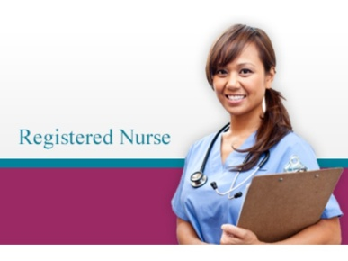
The nursing field extends many opportunities to be a very important part of the health care team. Nursing involves direct patient contact and varied skills and abilities. A nurse has a unique opportunity to ensure that they care for a patient’s comforts and needs, and can make a difference in every patient’s life. Various challenging opportunities are available under the broad category of nursing.
Nursing is one of the oldest and the most traditional professions in the world. Since Florence Nightingale made a revolutionary contribution in making it a full-fledged and disciplined profession, it has evolved to become one of the most popular medical jobs. Consequently, career opportunities in this profession are immense. As professionalism in nursing has gained momentum, those with certifications are given preference in the hiring process. With increasing challenges in hospital management and patient care, their range of duties have also increased tremendously. Nowadays, one can even specialize in a particular area, as there is a requirement for specialized skills in every department such as emergency rooms, ICUs, and childcare etc.
Intensive Care
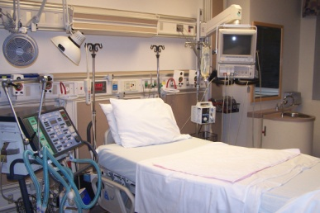
The intensive care unit (ICU) is a special ward allotted to critical patients who are struggling with life due to some disease or accident. In the ICU, patients require extra care and close monitoring due to their precarious medical condition. Here the nurses look after the proper functioning of the life-support equipment, feeding tubes, ventilators, and other systems installed to look after the patients. They also administer intravenous injections, medications, and insert catheters as per the need of the patients.
Pediatrics
Pediatric nurses treat babies, children, and adolescents. This field has gained immense popularity in recent years. Their duties range from administering drugs and injections to counseling a child, and emotionally supporting the tensed parents.
Neonatal nurse.
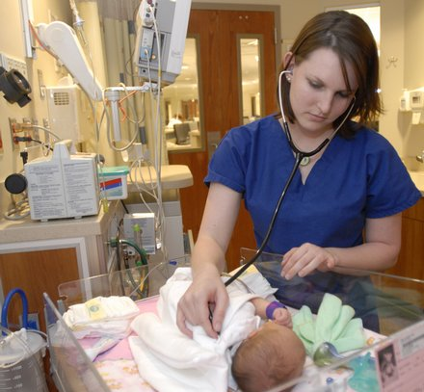
Neonatal nurses treat newborns with problems related to respiration and low weight at birth. They have to be skilled in feeding the baby with gavages tubes, at times when they are unable to eat or feed on the mother's milk. Monitoring the health of the baby and storing the information for future reference are important aspects of their job.

Besides an associate or a bachelor's degree in nursing, students must crack a national-level exam and get some work experience before applying for a license. Some employers look at a minimum of a bachelor's degree. The earning potential for registered nurses is very good and seeing the growth in this field, this profession holds promise for much better salaries and career development in the future.
http://www.buzzle.com/articles/registered-nurse-job-description.html

Exercise 4. Answer the following questions:
- What is nursing?
- Who made a revolutionary contribution in making it a full-fledged and disciplined profession?
- When can one specialize in a particular area, as there is a requirement for specialized skills in every department such as emergency rooms, ICUs, and childcare etc.?
- What is the intensive care unit (ICU)?
- What do the patients require in the ICU?
- What do nurses do in the ICU?
- What do pediatric nurses do?
- What are their duties?
- Whom do neonatal nurses treat?
Exercise 5. Match these definitions to the pictures:
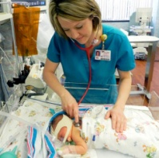 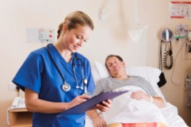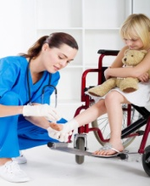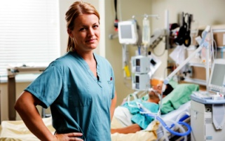A) Neonatal nurses B) Registered Nurse C) Pediatric nurse D) Intensive Care nurse

- She or he has a unique opportunity to ensure that they care for a patient’s comforts and needs, and can make a difference in every patient’s life.
- She or he treats newborns with problems related to respiration and low weight at birth.

- She or he treats babies, children, and adolescents.
- She or he looks after the proper functioning of the life-support equipment, feeding tubes, ventilators, and other systems installed to look after the patients. She or he administers intravenous injections, medications, and insert catheters as per the need of the patients.
Exercise 6. Read the sentences. Are these statements true (T) or false (F)?
- The nursing field extends many opportunities to be a very important part of the health care team.
- Nursing does not involve direct patient contact and varied skills and abilities.
Nursing is one of the newest and not the most traditional professions in the world.
- Nowadays, one can even specialize in a particular area, as there is a requirement for specialized skills in every department such as emergency rooms, ICUs, and childcare etc.
- In the ICU, patients don`t require extra care and close monitoring due to their precarious medical condition.
- Pediatric nurses treat babies, children, and adolescents.
- Neonatal nurses treat newborns with problems related to respiration and low weight at birth.
Exercise 7. Match the beginning of the sentences to their endings.
- Nursing is one | - very good and seeing the growth in this field, this profession holds promise for much better salaries and career development in the future.
- The intensive care unit (ICU) is | - newborns with problems related to respiration and low weight at birth.
- Their duties range from administering drugs | - a special ward allotted to critical patients who are struggling with life due to some disease or accident.
- Neonatal nurses treat | - of the oldest and the most traditional professions in the world.
- The earning potential for registered nurses is | - and injections to counseling a child, and emotionally supporting the tensed parents.

II. Obstetrics and Gynecology nurse.

Exercise 1. Read and learn the following words.
cancer [ˈkænsə]-рак
ovarian [əʊˈvɛːrɪən]-яичниковый
sterility [steˈrɪlɪtɪ]-бесплодие
consider [kənˈsɪdə]-считать, рассматривать
create [kri:ˈeɪt]-создавать, предлагать
prolonged [prəuˈlɔŋd]-длительный
breech [bri:tʃ]-ягодичное
necessitate [nɪˈsesɪteɪt]-требовать
conjunction [kənˈdʒʌŋkʃən]-вместе
ensure [ɪnˈʃuə]-гарантировать
safety [ˈseɪftɪ]-безопасность

Exercise 2. Translate the following word combinations from English into Russian before reading the texts.
Obstetrics nurses, gynecology nurses, reproductive diseases, chronic ovarian inflammation, prenatal nursing, delivery rooms, prolonged labor, a breech birth, significant discomfort, a Caesarean section, other complications, Nurse Midwives.

Exercise 3. Translate the following texts
Obstetrics and Gynecology nurse.

Obstetrics and Gynecology nurses often find themselves caring for women suffering from reproductive system diseases – like cancers of the reproductive system. Some of them deal with women suffering from chronic ovarian inflammation, sterility, etc.
There are two subspecialties of OB/GYN nurses and they are Prenatal Nursing and Labor and Deliver Nursing.
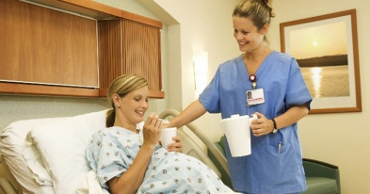
Prenatal nurse.
Prenatal nursing is a nursing specialty considered as a subset of Obstetrics and Gynecology nursing. In this field, the nurse cares for the women and their significant others before childbirth, during childbirth and after childbirth. These nurses have several important roles. They are also referred to as Obstetrics Nurses.
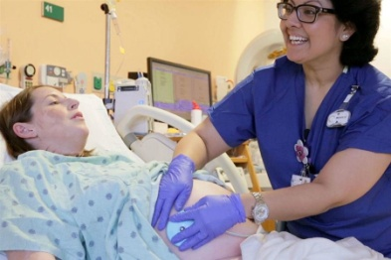

Labor and Delivery Nurse. Midwife.
Labor and Delivery Nursing is a nursing field involving care for women in labor and those women who have recently delivered. These nurses are often found in labor and delivery rooms. They also work with both doctors and midwives to help create a plan of care for both mother and baby. Prolonged labor may put the fetus at risk for stress and infection. A breech birth can cause significant discomfort and may necessitate a Caesarean section to deliver the baby. These and other complications require an obstetrics nurse to work quickly, in conjunction with the doctor, to ensure the safety of both the mother and infant. Labor and Delivery Nurses may also become Nurse Midwives.
Notes:
Labor is the whole process of the body getting the baby in position to be born and pushing the baby out. This can take many hours. Delivery is the part when the baby is actually coming out.

Exercise 4. Define the meaning of the following words. Match the words (a-c) to (1–3)
- Obstetrics and Gynecology nurses | - cares for the women and their significant others before childbirth, during childbirth and after childbirth.
- Prenatal nurse | - cares for women in labor and those women who have recently delivered.
- Delivery nurse | - care for women suffering from reproductive diseases – like cancers of the reproductive system.
Exercise 8. Read the sentences. Are these statements true (T) or false (F)?
1. Obstetrics and Gynecology nurses seldom find themselves caring for women suffering from reproductive diseases – like cancers of the reproductive system.
2. Prenatal nurse cares for the women and their significant others before childbirth, during childbirth and after childbirth.
3. Delivery nurse don`t also work with both doctors and midwives to help create a plan of care for both mother and baby.
Exercise 9. Chose the appropriate word from brackets
1. Obstetrics and Gynecology nurses often find themselves caring for women suffering from (respiratory system diseases, reproductive system diseases, skeletal system diseases) – like cancers of the reproductive system.
2. Prenatal nursing is a nursing specialty considered as a subset of (Surgical Nursing, Traumatologic Nursing, Obstetrics and Gynecology nursing).
3. Complications require an obstetrics nurse to work (quickly, slowly, do not to pay attention at all) in conjunction with the doctor, to ensure the safety of both the mother and infant.

III. Surgical Nursing
Exercise 1. Read and learn the following words.

skill [skɪl]-умения, навыки
motivation [ˌməutɪˈveɪʃən]-мотивация
ability [əˈbɪlɪtɪ]-способность
energy [ˈenədʒɪ]-энергичность, сила
successful [səkˈsesful]-успешный
safe [seɪf]-безопасный,
environment [ɪnˈvaɪərənmənt]-окружающая среда
coordination [kəuˌɔ:dɪˈneɪʃən]-координация
cooperation [kəuˌɔpəˈreɪʃən]-сотрудничество
capacity [kəˈpæsɪtɪ]-способность
procedure [prəˈsi:dʒə]-процедура
surgery [ˈsə:dʒərɪ]-операция
anesthesia [ˌænɪsˈθi:zjə]-анестезия
remain [rɪˈmeɪn]-оставаться
compose [kəmˈpəuz]-спокойный
pressure [ˈpreʃə]-напряжение
prior [ˈpraɪə]-предшествующий
preoperative[priːˈɒp(ə)rətɪv]- предоперационный
evaluate [ɪˈvæljueɪt]-оценивать
alert [əˈlə:t]-предупреждать
abnormality [ˌæbnɔ:ˈmælɪtɪ]-отклонение
identity [aɪˈdentɪtɪ]-подлинность
readiness [ˈredɪnɪs]-готовность
retrieve [rɪˈtri:v]-подготавливать
circulating ˈsə:kjuleɪtɪŋ]-дежурная
accompany [əˈkʌmpənɪ]-помогать
surgeon [ˈsə:dʒən]-хирург
requested[rɪˈkwestɪd]-требуемый
anesthesia [ˌænɪsˈθi:zjə]-анестезия
scrub [skrʌb]-операционная
sterile [ˈsteraɪl]- стерильный
handle [ˈhændl]-обращаться
retractor [rɪˈtræktə]-ранорасширитель
suture [ˈsju:tʃə]-шов
conscientious [ˌkɔnʃɪˈenʃəs]-добросовестный
visualization [ˌvɪzjuəlaɪˈzeɪʃən]- отчётливый зрительный образ
retracting[rɪˈtræktɪŋ]-убирать
efficiently[ɪˈfɪʃntli]- эффективно
scope [skəup]- устройство для наблюдения
staple [ˈsteɪpl]-наложить скобы
incision [ɪnˈsɪʒən]- основной разрез
rural [ˈruərəl]-сельский, деревенский
sole [səul]-единственный
collaboration [kəˌlæbəˈreɪʃən]-сотрудничество
recovery [rɪˈkʌvərɪ]-выздоровление
transition out [trænˈsɪʒən]-выводить из
critical [ˈkrɪtɪkəl]-критический
related [rɪˈleɪtid]-иметь отношение к
issue [ˈɪʃu:]-проблема

Exercise 2. Translate the following word combinations from English into Russian before reading the texts.

Surgical Nursing, the operating room, the recovery room, a part of a team, the actual procedure, stressful situations, a preoperative nurse, patient`s identity, the patient`s medical history, the circulating nurse, apply monitors, additional equipment, the recovery nurse, the scrub nurse, holding retractors, cutting sutures, the special training, retracting tissue, nurse anesthetist, the postoperative nurse.

Surgical Nursing

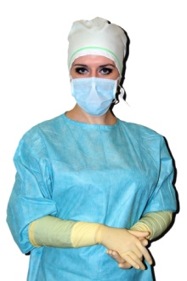
Surgical Nursing is the job for nurses in the operating room, surgery and recovery room.

Surgical nursing jobs (jobs for nurses in the operating room) require skill, motivation and energy and the ability to function well as part of a team.
A successful and safe operating room environment requires coordination and cooperation from the professionals who work there. Nurses in and around the operating room function in many capacities from getting the patient ready for surgery, to assisting in the actual procedure to the recovery of the patient from their surgery and anesthesia. These nurses all deal with stressful situations and must remain composed under pressure.

The preoperational Nurse

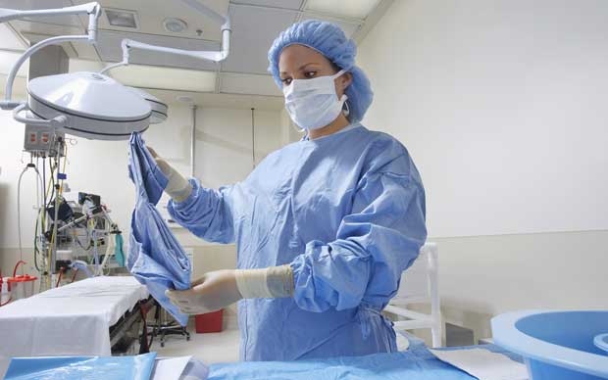
Prior to going to the actual operating room, a preoperative nurse will see and evaluate patient. Patient`s identity and surgical procedure will be identified. The preoperational nurse will make sure all laboratory tests have been done and will alert the doctors to any abnormalities. He or she reviews the patient`s medical history and also places in preoperating room and start to give a patient fluids or antibiotics as requested by patient`s surgeon.

Circulating Nurse
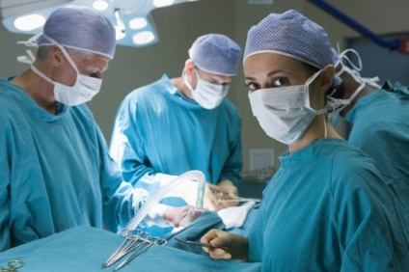
If the patients are having surgery, the circulating nurse also checks patient`s identity and readiness for surgery. She or he confirms the procedure being performed and makes sure patient understand and agree with the procedure being done, just as the preoperative nurse does.
The circulating nurse accompanies the patient to the operating room. Before the operation starts, the circulating nurse helps the anesthesiologist apply monitors and make sure patient is as comfortable as possible. After patients are asleep, the circulating nurse helps the surgeon by making sure equipment such as monitors for cameras work properly. This nurse also retrieves additional equipment as requested by the surgeon.
At the end of the operation, the circulating nurse again assists the anesthesiologist as patient wake up from the anesthesia and accompanies patient to the recovery room. The circulating nurse gives report and transfers care to the recovery nurse.

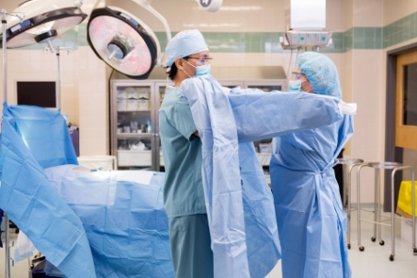
Scrub Nurse
The scrub nurse is so named because he or she is "scrubbed" into the sterile procedure. They handle only sterile instruments and hand instruments to the surgeon. They also help by holding retractors and cutting sutures. Scrub nurses must be conscientious and alert to stay sterile throughout the procedure.

RNFA
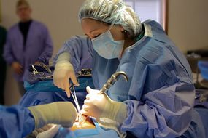
RNFA stands for "registered nurse, first assistant". The RNFA is a nurse who has received special training to assist the surgeon during the operation. He or she helps to maintain visualization of the surgical field, retracting tissue and clearing blood from the field help the surgeon operate more efficiently. During procedures done with scopes (laparascopes inside the abdomen, arthroscopes inside joints), the RNFA may hold the camera for the surgeon.
At the end of the operation, the RNFA may suture or staple the incision. RNFAs have attended both classroom and laboratory courses to learn these advanced skills.

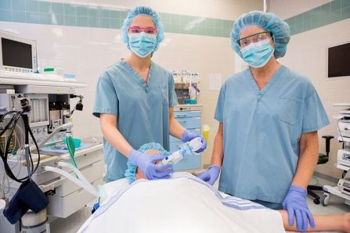
Nurse Anesthetist (CRNA)
Patient`s anesthesia provider may be either an anesthesiologist (a medical doctor) or a CRNA, a "certified registered nurse anesthetist", or both. In some rural areas, CRNAs work independently and are the sole anesthesia providers. In other areas, one or more CRNAs work in collaboration with an anesthesiologist to provide necessary anesthesia services.
A CRNA or nurse anesthetist is an experienced registered nurse who then goes on to obtain more schooling and training in anesthesia.

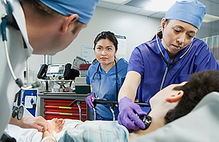
Recovery Room Nurse.
After the operation, a recovery room nurse takes over care. He or she helps patient transition out of patient `s anesthesia. Monitoring vital signs, administering medications and giving post-operative instruction all fall under the scope of practice of a recovery nurse.
Many institutions require recovery nurses to have experience in critical care. The postoperative nurse must be able to identify and begin treating problems that may arise after surgery. This includes problems related to surgery like increased bleeding and anesthesia or patient related issues such as low oxygen levels and changes in heart rate or rhythm.

Exercise 4. Guess what nurse it is
- Nurses in and around the operating room function in many capacities from getting the patient ready for surgery, to assisting in the actual procedure to the recovery of the patient from their surgery and anesthesia. | - The preoperative nurse
- He or she reviews the patient`s medical history and also places in preoperating room and start to give a patient fluids or antibiotics as requested by patient`s surgeon. | - RNFA
- He or she helps patient transition out of patient `s anesthesia, monitoring vital signs, administering medications and giving post-operative instruction all fall under the scope of practice of a recovery nurse. | - Scrub Nurse
- They handle only sterile instruments and hand instruments to the surgeon. They also help by holding retractors and cutting sutures. | - Surgical nurse
- He or she helps maintain visualization of the surgical field. Retracting tissue and clearing blood from the field help the surgeon operate more efficiently. | - Recovery Room Nurse

Exercise 4. Answer the following questions:
1. What is Surgical Nursing?
2. Where does the surgical nurse work?
3. What situations the surgical nurses deal with?
4. What does the preoperative nurse do?
5. What does the circulating nurse do before the operation?
6. What does the circulating nurse do at the end of the operation?
7. What is the scrub nurse?
8. What does the scrub nurse do during operation?
9. What does RNFA do during operation?
10.What does the recovery room nurse do after the operation?

Exercise 5. Choose the appropriate word
1. Surgical Nursing is the job for nurses in the ______ room, surgery and recovery room.
a) operating; b) dressing; c) laboratory
2. The circulating nurse helps the __________ apply monitors and make sure patient is as comfortable as possible.
a) therapist; b) anesthesiologist; c) gynecologist
3. RNFA helps to maintain ______________ of the surgical field, retracting tissue and clearing blood from the field help the surgeon operate more efficiently.
a) blindness; b) darkness; c) visualization

